**DATA STORY TELLING**

1. **Conversion Rate**

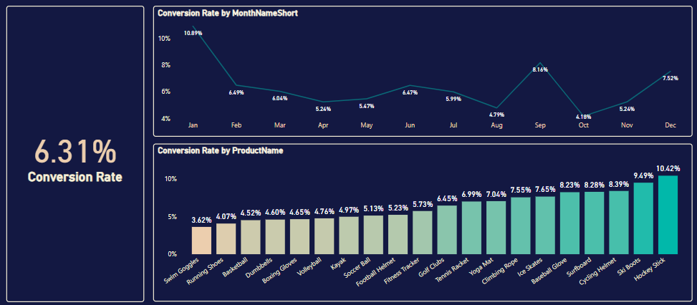

* The average conversion rate is 6.31%, indicating that the business is making relatively good efforts and achieving results in converting visits into purchasing customers.
* However, the chart "Conversion Rate by Product Name" shows that some products, such as "Swim Goggles", "Running Shoes", "Basketball", "Boxing Gloves", "Volleyball", and "Kayak" have conversion rates lower than the average. These products need to be analyzed and improved.
* The chart "Conversion Rate by Month" indicates that the conversion rate fluctuates from month to month, with January having the highest rate, while August and October show significantly lower rates. It is necessary to investigate the reasons behind this fluctuation.

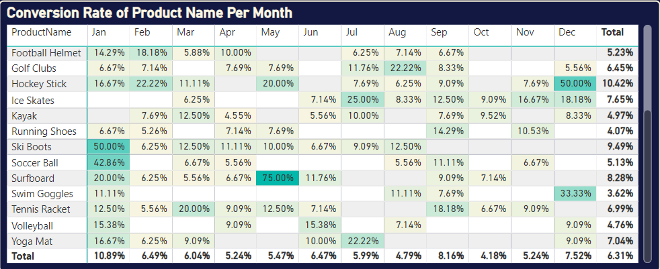

* In the above report, it can be seen that in August and October, the conversion rate by product is lower than 2% compared to the yearly average. It is necessary to analyze whether these products are being marketed effectively to people whose circumstances align with the product's usage needs.
* **Some suggestions for improving the conversion rate:**:
* Conduct a deep analysis of products with low conversion rates, such as "Swim Goggles", "Running Shoes", "Basketball", "Boxing Gloves", "Volleyball", and "Kayak" to identify issues related to product page design, marketing content, pricing, customer experience, etc.
* Propose improvement solutions such as updating product page designs, adjusting pricing, and enhancing customer service.
* Investigate the reasons behind the monthly fluctuations in conversion rates, considering whether there are seasonal factors or special events that may have an impact, and develop appropriate marketing plans.
* Continue to monitor, measure, and evaluate the effectiveness after implementing the improvement solutions.

1. **Engagement for Campaigns**

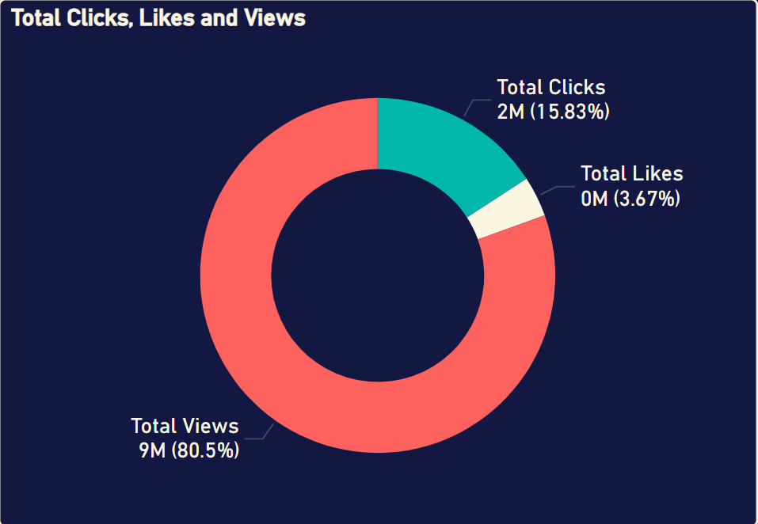

* The marketing campaign is attracting 9 million views and 2 million clicks. However, the number of likes and clicks is significantly lower compared to the views, indicating that the company's marketing efforts are generating interest and brand recognition among customers.

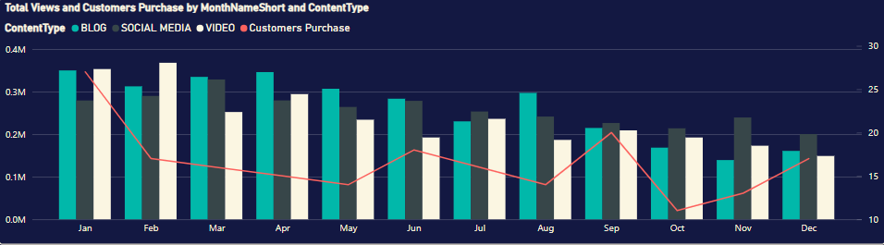

* However, the chart above shows that some advertising campaigns in the last four months of the year have significantly lower engagement compared to the previous eight months.

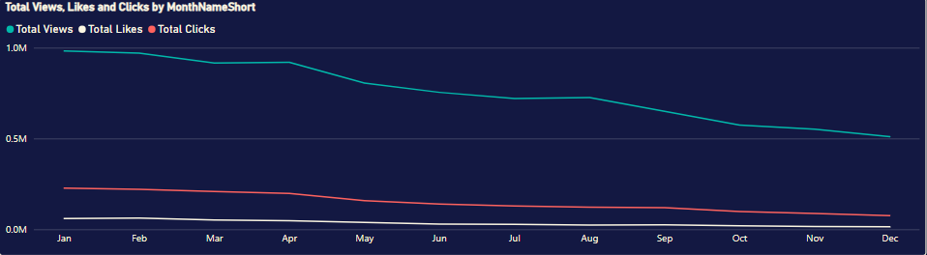

* Additionally, the chart "Total Views, Likes, and Clicks by Month Name Short" shows a noticeable decline in engagement, with the most evident drop in views occurring during the last four months of the year. It is necessary to analyze these campaigns to identify the causes.
* **Some Suggestions for Enhancing Customer Engagement**:
* Conduct a deep analysis of marketing activities with low engagement during the last four months to understand the reasons: whether the content, images, and videos are appealing; if the distribution channels are suitable for the target audience; and whether the timing of the campaigns is effective.
* Experiment with improving factors such as content, distribution channels, and timing of these campaigns, and compare their effectiveness.
* Additionally, maximize the use of effective platforms like blogs while seeking ways to improve less effective platforms.
* Continue to monitor, measure, and evaluate the effectiveness after implementing the changes.

1. **Customer's Reviews**

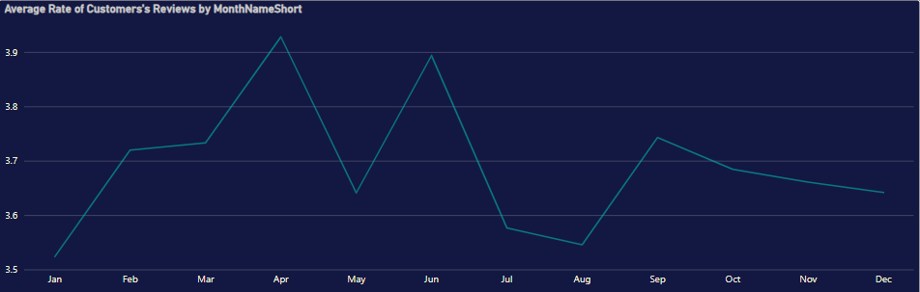

* The average customer rating is 3.69, indicating that customer satisfaction is not high. The chart "Average Rate of Customer Reviews by Month Name Short" shows significant fluctuations over time. It is particularly evident that January, July, and August had much lower average ratings compared to the other months. It is necessary to analyze why January has a high conversion rate but also receives the most negative reviews.
* The negative feedback that customers often mention includes: a normal experience with nothing special, disappointment with this performance, and that these products perform very poorly when used. Based on the issues that customers are dissatisfied with, improvements should be made to both product quality and service.

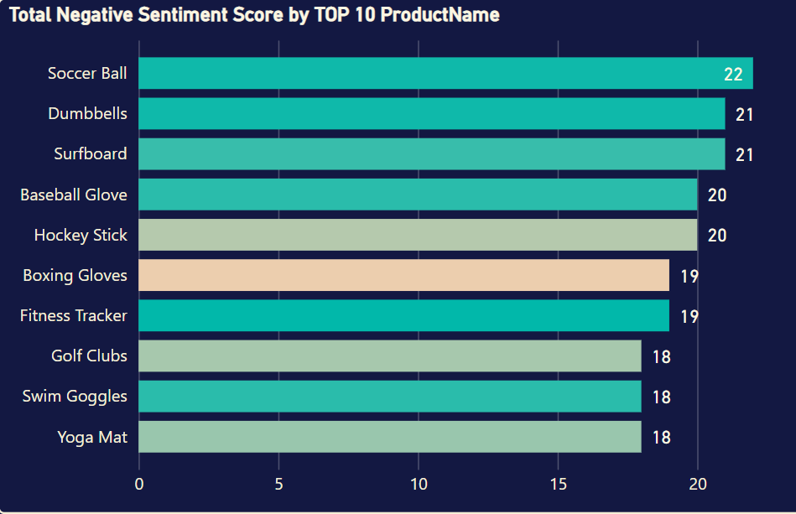

* We can see that the top 10 products with the most negative feedback come from customers. It's important to analyze the reasons these products are receiving negative feedback. Is it due to product quality, pricing, targeting the wrong audience in advertising, misleading communications, or a lack of features?
* **Some Suggestions for Improving Customer Feedback**:
* Conduct a detailed analysis of both negative feedback and incomplete positive feedback to identify common themes, such as product quality, customer service, and shopping experience. This will help address the underlying issues affecting customer experiences.
* Based on the analysis, propose improvement solutions such as:

+ Enhancing the product quality inspection process to address defects or issues.

+ Strengthening communication to accurately promote the product's content.

+ Expanding the customer service team and improving the feedback handling process.

+ Enhancing the shopping experience by optimizing the ordering and delivery processes.

+ Continuing to monitor and measure customer feedback after implementing the improvement solutions.